**Assignment -4**

|  |  |
| --- | --- |
| Student Name | Priyadharshini S |
| Student Roll Number | 737819CSR149 |
| Maximum Marks | 2 Marks |

**Question-1:**

Pull an image from the docker hub and run it in the docker playground

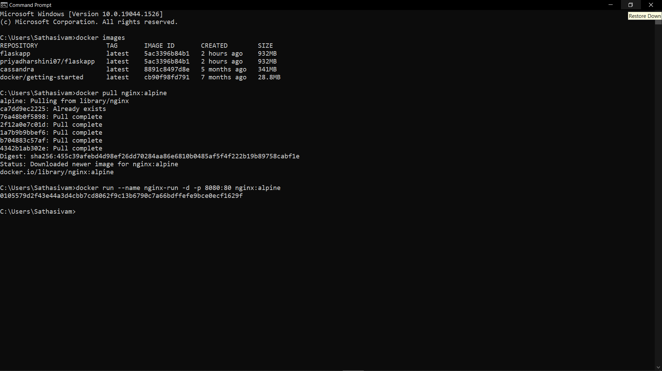

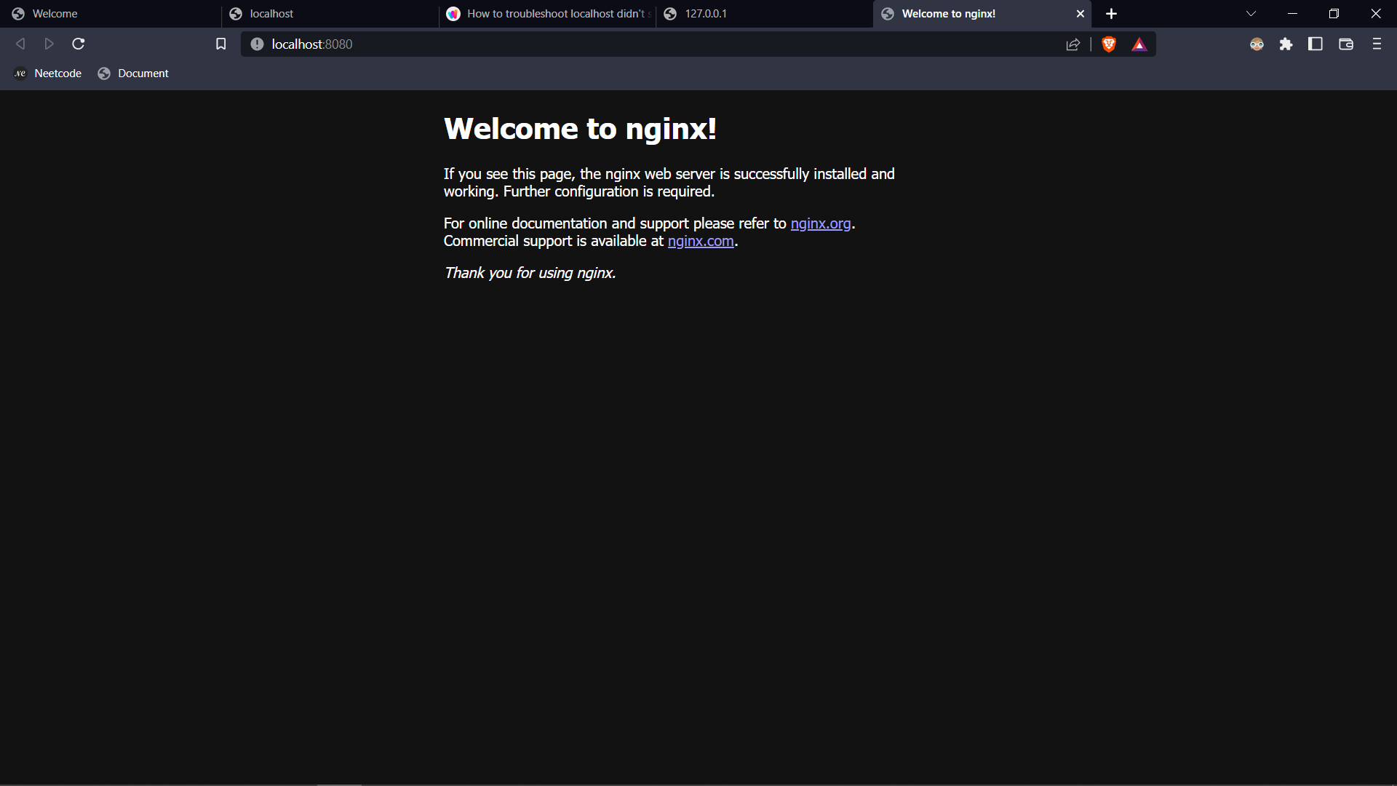

**Question 2:**

Create a docker file for the helloworld or job portal application and deploy it in docker desktop

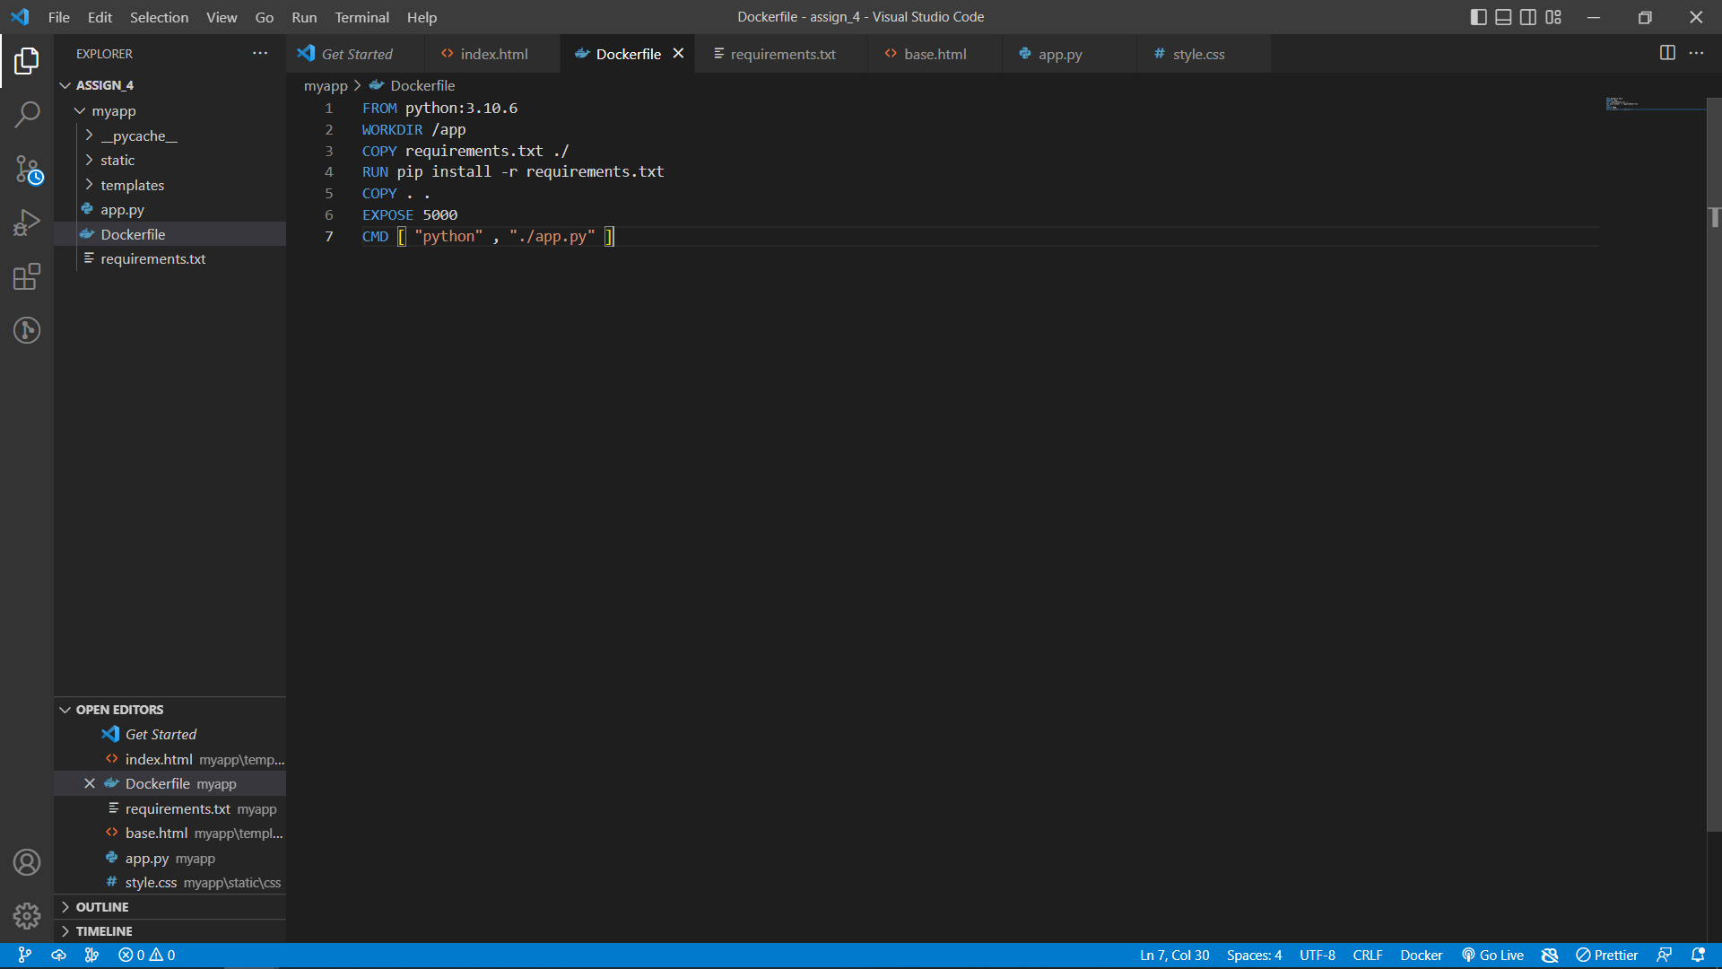

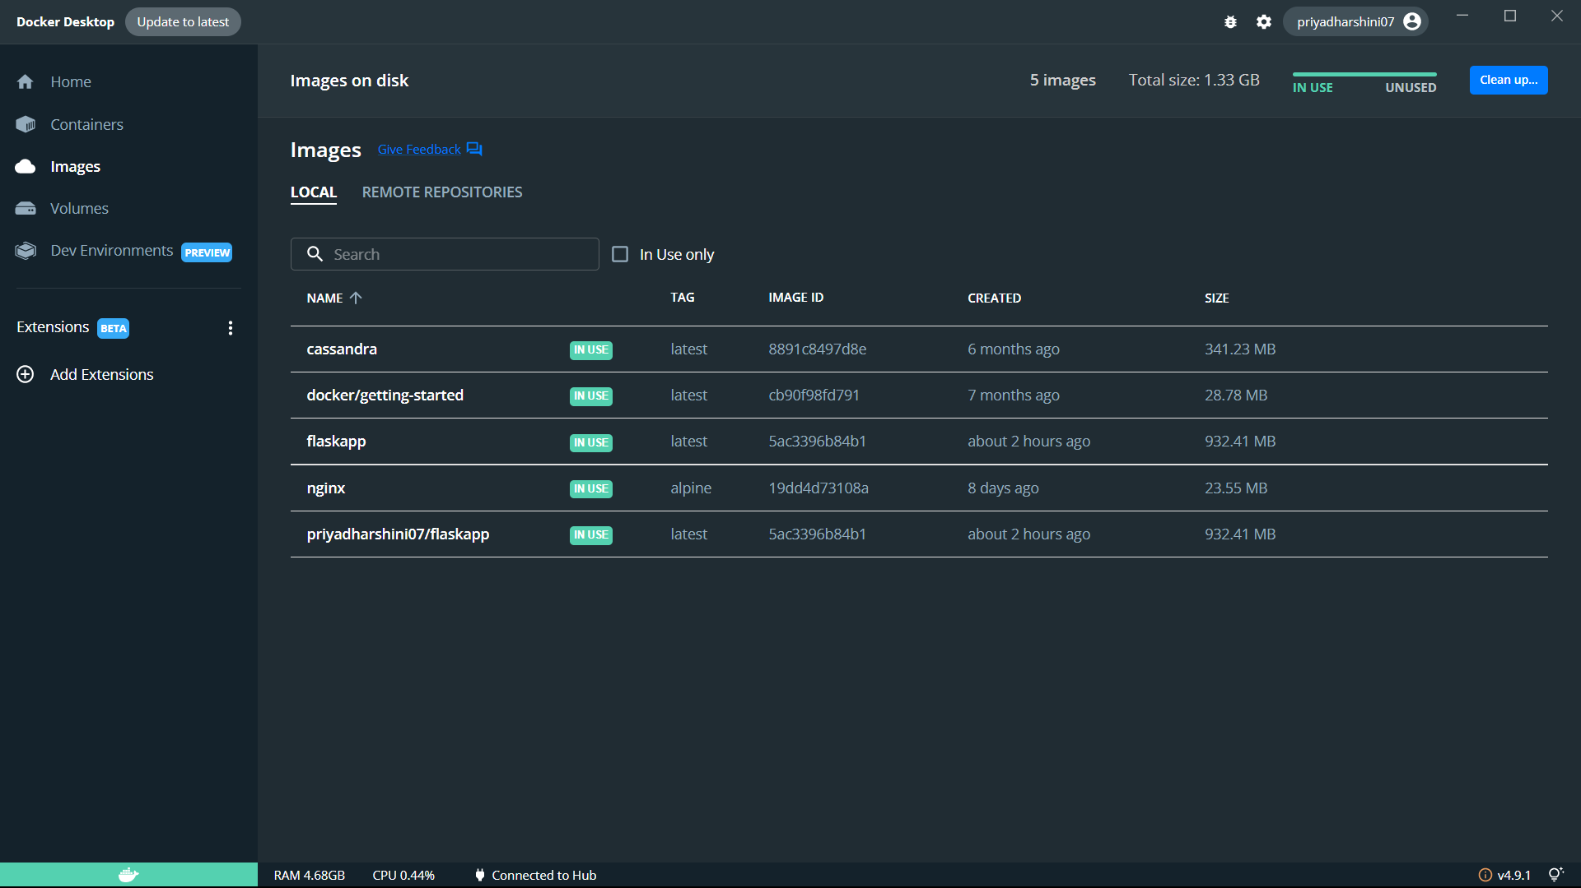

**Question 3:**

Create a IBM container registry and deploy helloworld app or jobportalapp.

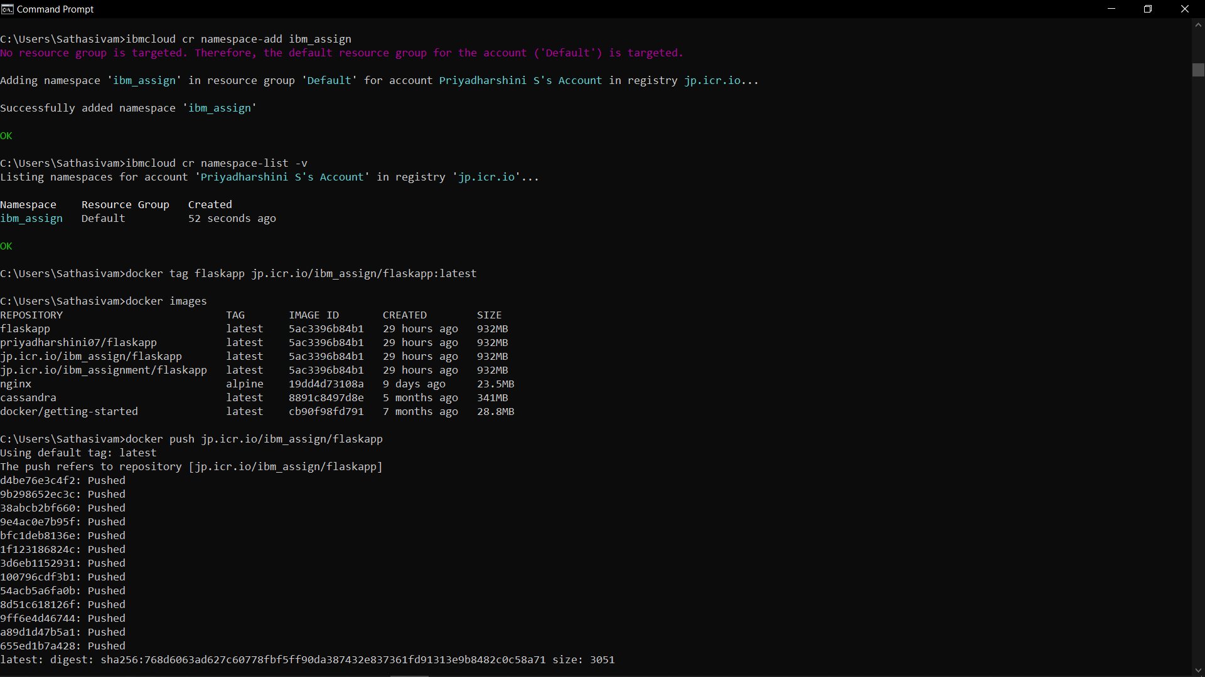

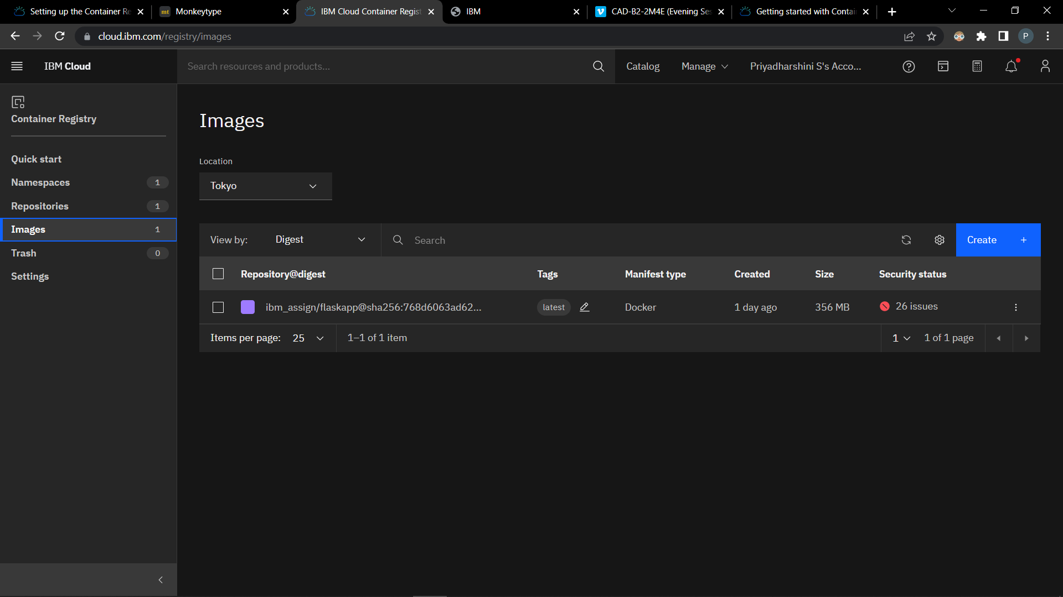

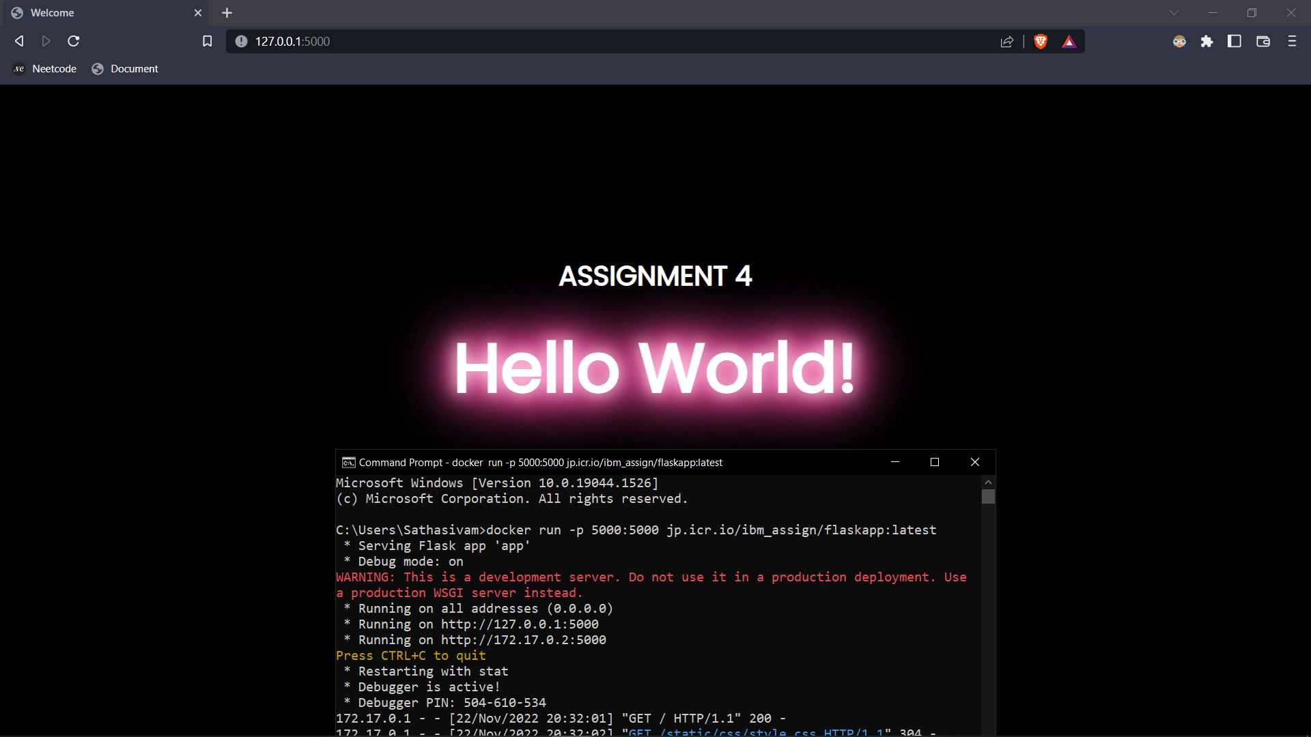

**Question 4:**

Create a Kubernetes cluster in IBM cloud and deploy helloworld image or jobportal image and also expose the same app to run in nodeport.

